
2008
Mr. William Birch
Crowlands Driving School ©
10/1/2008
A Guide to Gaining the LGV Licence
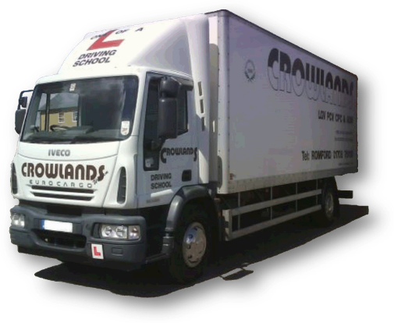

Contents
A Guide to gain the LGV Licence 3
1) Provisional Licence 3
a) Filling in the D2 Form 3
i) Section 1 – What are you applying for? 3
ii) Section 2 – Your Details 4
iii) Section 3 – Your eyesight and your hearing 4
iv) Convictions 4
v) Section 4 – Your Health 5
vi) Section 5 – Your Contact Details 6
vii) Section 6 – Your Proof of Identity 6
viii) Section 7 – Signing a Photo to verify identity 6
ix) Section 8 – Your Declaration 7
b) Filling in the D4 Form 7
c) Sending off for your provisional licence 8
d) Receiving your new licence 8
2) So you have your provisional licence... 9
3) The LGV Theory Test 9
a) Preparing for the Theory Test 10
b) Booking the Theory Tests 11
c) Passing the Theory Tests 12
4) READY TO GO! 12

A Guide to gain the LGV Licence

Provisional Licence
The first step to get an LGV licence is to apply for the provisional license for the category you wish to pass.

To apply for a provisional licence, you have to first obtain the official DVLA forms namely a D2 & D4 form (D2 pack). These forms can be obtained directly from us or online.

Filling in the D2 Form
The D2 form is an Application for Lorry, Bus or Minibus Driving Licence. This is the form you yourself will have to fill out.
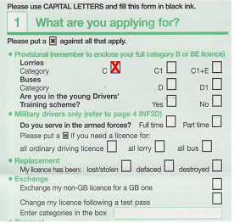

Section 1 – What are you applying for?
In this section, you have to ‘cross’ what you are applying for.

Under provisional you have a number of categories. For information on these categories, please visit our website or contact us on 01708 761110.

If you ever wish to take a bus licence, you can also ‘cross’ this category as well as it will save you ever having to do the medical examination again.

If you have lost either part of your current driving licence, i.e. your photocard or paper counterpart, then you should also ‘cross’ the relevant box under Replacement.
Please note that there is a fee for replacement licences. All current prices can be viewed online by clicking HERE.

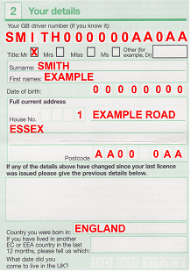
Section 2 – Your Details
This section is pretty simple. All you have to do is fill out your details.

If your current address is different from the one on your licence, just put the old address in the empty box provided.

Section 3 – Your eyesight and your hearing
This section concentrates on whether your eyesight and hearing are suitable for the licence you are hoping to gain. Simply ‘cross’ the boxes with the answer you wish to give.

Convictions
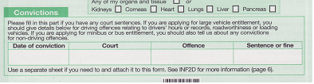
You must state all motoring convictions that relate to speed, driver’s hours or records, roadworthiness or loading vehicles. You must state all convictions within the last four years.

Section 4 – Your Health
This section is extremely important and is based on the list of eyesight and medical conditions below:

Persistent alcohol misuse or dependency | A01
Any type of brain surgery, severe head injury involving in-patient treatment, or brain tumour | B03
Any form of Stroke including TIA | B08
Diabetes controlled by insulin | D01
Diabetes controlled by tablets | D02
Persistent drug misuse or dependency | D08
Epilepsy | E01
Fits or blackouts | E03
Repeated attacks of sudden disabling giddiness | G03
Angina, other heart condition or heart operation | H01
An implanted cardiac pacemaker | H04
An implanted cardiac defibrillator (ICD) | H37
Any persisting limb problem which needs driving to be restricted to certain types of vehicles or those with adapted controls | L02
A serious problem with memory or periods of confusing | M04
Any other chronic neurological condition | M08
Severe learning disability | M14
Serious psychiatric illness or mental ill health | M99
Narcolepsy | N01
Sleep apnoea syndrome | S05
Parkinson’s disease | P01
Any condition affecting either eye  Not including colour blindness or short or long sight | V01
Any condition affecting visual field | V06
Total loss of sight in one eye | V10
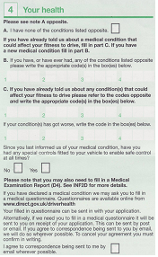

You must read this section very carefully and make sure to write in the right codes relevant to your illness, if any.

If you do not feel you have any of the conditions stated, then simply ‘cross’ the relevant box.

Section 5 – Your Contact Details
All you need to do here is fill in your daytime telephone number and an email address if you have one.
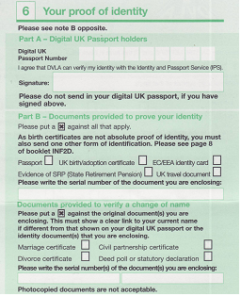

Section 6 – Your Proof of Identity
You DO NOT need to fill out this section if you have a Photocard Driving licence i.e. a photocard licence and a paper counterpart (Unless changing your name).
If you currently have an old paper licence, you must supply some proof of your identity.
The best and easiest proof of identity is a passport.
If your passport is digital, then you can simply put your passport number in the relevant boxes and sign to say that DVLA can view your details.
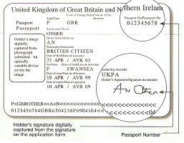
Your passport is digital if both your signature and passport number appear on the same page.

If your passport is not digital or you do not hold a passport, then you fill out PART B. Simply ‘cross’ which document you are sending to provide proof of your identity.

Section 7 – Signing a Photo to verify identity
You DO NOT need to provide a photograph when applying for a provisional licence so ignore this section
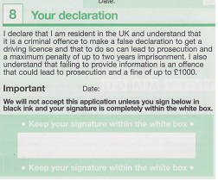
    - Section 8 – Your Declaration
Simply date and sign.
Make sure that your signature is within the white box.

Filling in the D4 Form
The D4 Form is a Medical Examination Report and needs to be completed by a doctor during a medical examination.
Any doctor can do this but at a price. The average charge nowadays is £120 although some have even charged up to £300.
We recommend one of the following which we know about:
- OHN Medical Centre
22 High Street,
Aveley,
Essex
RM15 4AD
TEL: 01708 865128
Price: £45

- www.driversmedicals.com
Centres throughout the UK
TEL: 0870 609 1540
Price: £49

Sending off for your provisional licence
Now that both the D2 and D4 forms have been filled in, you simply need to send off both forms along with BOTH PARTS of your current driving licence (Photocard & paper counterpart) to DVLA in the envelope provided with the forms. If not, the address is as follows:
Vocational Licence Section
Driver & Vehicle Licensing Agency
SWANSEA
SA99 1BR

Receiving your new licence
Your provisional licence should take 10-15 working days to arrive. If you have not received it or you wish to track the progress of your application, call DVLA on 0870 240 0009.
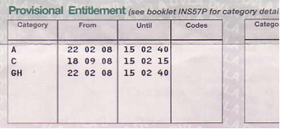
Once you receive your licence you should check you have gained the provisional by looking to see if you have the relevant category under ‘Provisional Entitlements’.

So you have your provisional licence...
Now that you have your provisional licence, we would like to offer you a FREE on-road assessment with no obligation.

The assessment not only allow us to assess you on your ability and give you guidance on how many days training you will need, but it will also allow you to assess us a company and see how we work.

The assessment lasts for 30 minutes and can be carried out nearly every weekday.

To book your FREE assessment, please call the office on
(01708) 761110

Please be aware that the assessment is not required if you don’t wish to have one.

The LGV Theory Test
Before you can go on to take a practical driving test, the LGV theory test need to be passed.
The test is broken down into two tests:
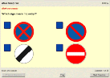
- LGV MC (Multiple Choice) Test – In this test, you will be sat at a touch-screen computer screen and will be asked 100 multiple choice questions in which you have 115 minutes to answer.

To pass the test, you simply have to click the correct answer(s) and then move on to the next question. The pass mark is 85 out of 100.
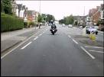
LGV HP (Hazard Perception) Test – In this test, you will be sat again at a touch-screen computer screen. You will be presented with 19 video clips which are in first-person perspective and feature every day road scenes.

To pass the test, you simply have to click the computer mouse when you see a hazard developing. The maximum score you can achieve on each hazard is 5. The pass mark is 67 out of 100.

Preparing for the Theory Test
In order to revise for the theory tests, there are a number of Official DSA publications which you can purchase from us directly or from DSA online.

To revise for the LGV MC Test, you will need to purchase one of the following:
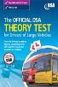
- The Official DSA Theory Test for Drivers of Large Vehicles 08/09 Edition
Description: This is the official book that includes all of the theory test questions for drivers of large vehicles and explains the answers.
Format: Book
ISBN: 978-0115529030 RECOMMENDED
Price: £15.99

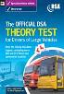
- The Official DSA Theory Test for Drivers of Large Vehicles 08/09 Edition
Description: This is the official CD-ROM that includes all the theory test questions for drivers of large vehicles and explains the answers.
Other Features include Voice-over for dyslexia and reading difficulties
Format: CD-ROM
ISBN: 978-0115529047
Price: £35.00

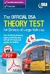
- The Official DSA Theory Test for Drivers of Large Vehicles 08/09 Edition
Description: Brand new downloadable version of the book.
ONLY AVAILABLE FROM DSA WEBSITE
Format: Downloadable PDF
ISBN: 978-0115530081
Price: £15.99

To revise for the LGV HP Test, you will need to purchase the following:

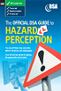
- The Official DSA Guide to Hazard Perception
Description: The only Official Interactive DVD that explains how the Hazard Perception test works.
Format: DVD
ISBN: 978-0115528651
Price: £15.99

There are also other publications which we recommend purchasing to help you gain your licence:

- The Official Highway Code
Description: Essential reading detailing all current UK road law including speed limitations.
Format: Book
ISBN: 978-0115528149 RECOMMENDED
Price: £2.50


- Knowing your Traffic Signs
Description: A handy reference that illustrates and explains the vast majority of traffic signs that a road user is most likely to encounter.
Format: Book
ISBN: 978-0115528552
Price: £4.99

Booking the Theory Tests
Once you have revised and you feel you are ready for the theory test, you can either book them yourself online through DSA, via telephone on 0300 200 11 22 or via us at the same time you have your FREE assessment.

The cost of the theory tests are as follows:
- LGV HP (Hazard Perception) Test - £15.00
- LGV MC (Multiple Choice) Test - £35.00

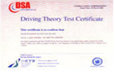
Passing the Theory Tests
Once you have passed both units of the LGV theory test you will receive an embossed pass certificate letter in the post along with your theory certificate number.

READY TO GO!
Now that you have gained your provisional and passed your LGV theory test, you are all ready to go for your practical training.
Courses can be built around the individual and be customised to suit all needs.
For more information, current prices or to book, please phone us on
(01708) 761110


